ANEXO 16
Áreas prioritarias de protección contra incendios forestales.

El cálculo de superficie (ha) de las áreas prioritarias de protección contra incendio forestales por municipio se estimó con el Límite geoestadístico INEGI 2022, que define los límites territoriales de los 125 municipios del estado de Jalisco.

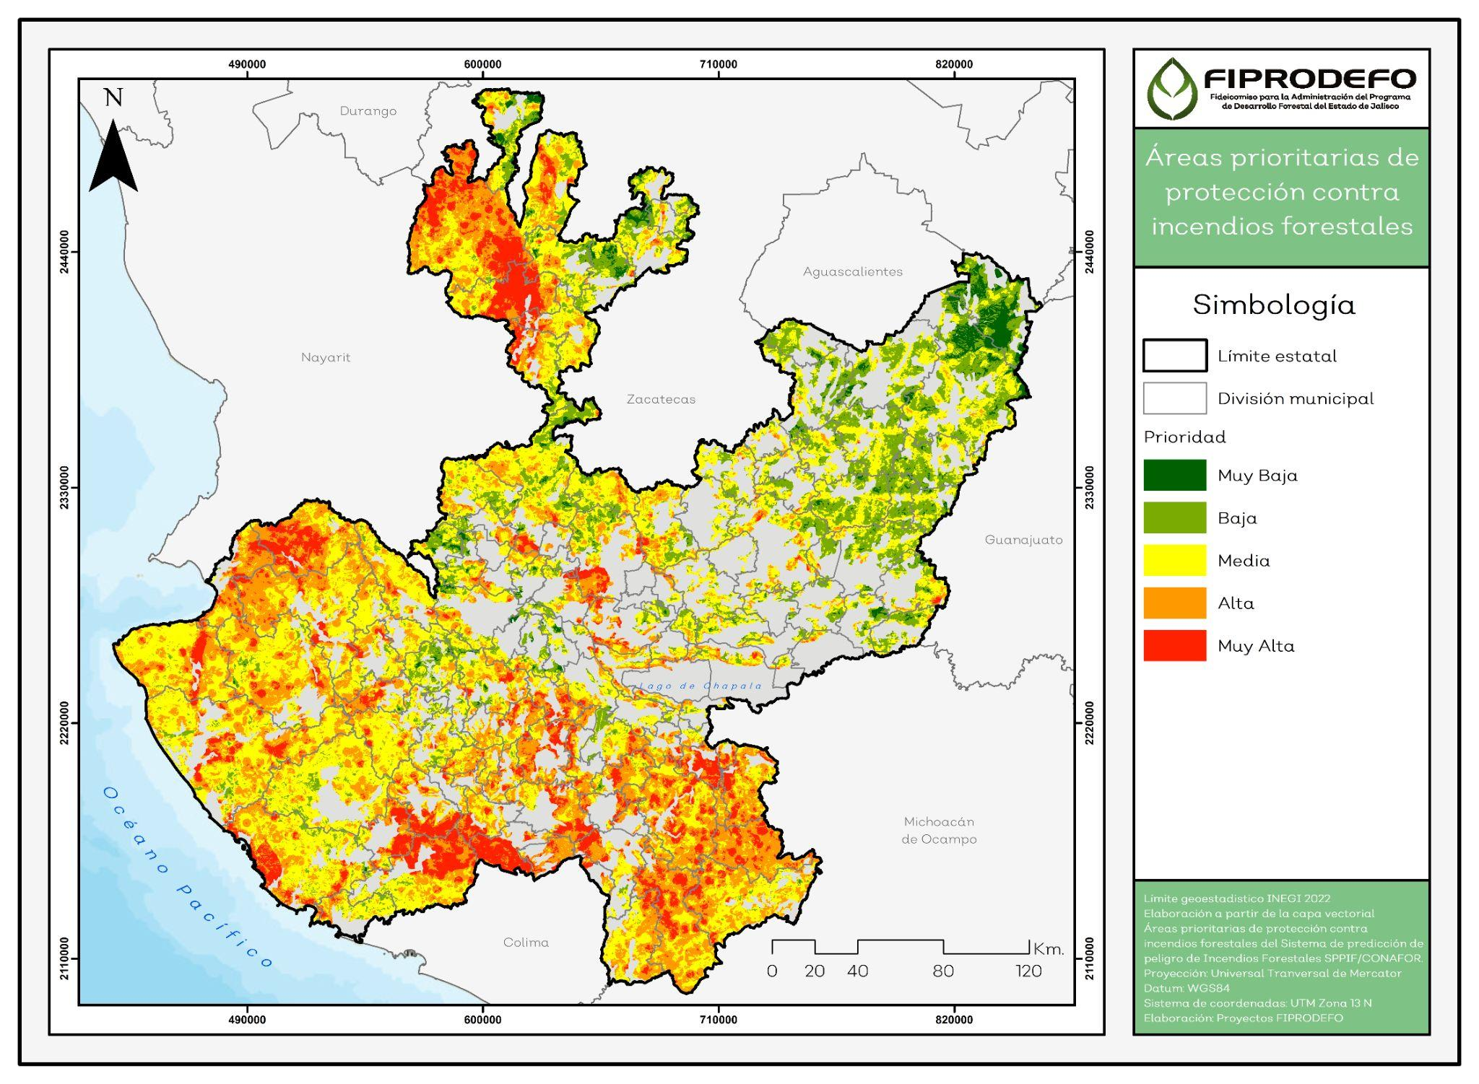

Tabla 1. Superficie y grado de prioridad de protección contra incendios forestales por municipio.
Clave Municipal | Municipio | Región | Grado de prioridad (ha)
 |  |  | Muy Alta | Alta | Media | Baja | Muy Baja
061 | Mezquitic | NORTE | 81,326.56 | 142739.58 | 89420.84 | 14089.39 | 518.77
019 | Bolaños | NORTE | 41109.85 | 21265.74 | 20729.09 | 1621.31 | 0.00
027 | Cuautitlán de García Barragán | COSTA SUR | 36515.81 | 37129.29 | 40870.22 | 3846.90 | 78.62
080 | San Sebastián del Oeste | COSTA-SIERRA  OCCIDENTAL | 33693.83 | 50681.92 | 22297.30 | 604.27 | 1.18
099 | Tolimán | SUR | 28203.19 | 7266.12 | 1338.28 | 6.28 | 0.00
043 | La Huerta | COSTA SUR | 25164.62 | 53790.79 | 87419.77 | 9469.03 | 295.15
087 | Tecalitlán | SUR | 24738.49 | 67888.31 | 32682.45 | 205.67 | 0.00
085 | Tamazula de Gordiano | SUR | 24095.46 | 65676.93 | 35996.83 | 336.67 | 0.00
100 | Tomatlán | COSTA SUR | 20618.68 | 82464.46 | 133988.77 | 12182.65 | 126.84
015 | Autlán de Navarro | SIERRA DE AMULA | 19048.41 | 17866.54 | 14028.94 | 194.38 | 0.00
056 | Santa María del Oro | SURESTE | 15383.94 | 53910.32 | 6627.63 | 56.09 | 0.00
021 | Casimiro Castillo | COSTA SUR | 14714.49 | 12347.85 | 7511.92 | 1345.09 | 3.45
020 | Cabo Corrientes | COSTA‐SIERRA  OCCIDENTAL | 14211.75 | 51917.38 | 81694.54 | 1778.84 | 0.00
059 | Mazamitla | SURESTE | 12987.48 | 8023.84 | 1587.77 | 22.92 | 1.73
058 | Mascota | COSTA‐SIERRA  OCCIDENTAL | 12800.11 | 79061.05 | 68154.24 | 1189.06 | 5.18
113 | San Gabriel | SUR | 12468.92 | 21879.25 | 13275.60 | 348.39 | 0.00
120 | Zapopan | CENTRO | 11205.40 | 22609.30 | 23470.01 | 13024.27 | 858.35
069 | Quitupan | SURESTE | 10960.22 | 32993.41 | 16480.85 | 677.46 | 4.33
067 | Puerto Vallarta | COSTA‐SIERRA  OCCIDENTAL | 10674.12 | 33148.68 | 11055.18 | 366.89 | 88.85
049 | Jilotlán de los Dolores | SUR | 10590.29 | 54571.56 | 59279.19 | 2649.40 | 75.90
086 | Tapalpa | LAGUNAS | 10346.54 | 22763.35 | 6963.42 | 309.83 | 1.73
084 | Talpa de Allende | COSTA-SIERRA  OCCIDENTAL | 10346.33 | 66017.69 | 86501.63 | 6890.95 | 275.81
108 | Tuxpan | SUR | 8735.13 | 13313.48 | 14409.32 | 1290.71 | 9.14
076 | San Martín de Bolaños | NORTE | 8724.89 | 17210.64 | 22499.46 | 9139.98 | 0.00
106 | Tuxcacuesco | SIERRA DE AMULA | 8196.44 | 12273.81 | 9946.42 | 234.69 | 2.65
010 | Atemajac de Brizuela | LAGUNAS | 6758.17 | 12454.64 | 7582.05 | 74.93 | 0.00
028 | Cuautla | SIERRA DE AMULA | 6040.66 | 15341.80 | 10711.92 | 1382.69 | 88.33
065 | Pihuamo | SUR | 5967.53 | 32349.74 | 31583.71 | 615.16 | 0.00
094 | Tequila | VALLES | 5713.59 | 28393.28 | 75438.50 | 37658.26 | 3921.37
031 | Chimaltitán | NORTE | 5409.44 | 15143.93 | 31677.10 | 4401.06 | 0.75
097 | Tlajomulco de Zúñiga | CENTRO | 5073.33 | 12090.10 | 9141.52 | 2254.82 | 79.98
079 | Gómez Farías | SUR | 5037.48 | 14920.15 | 9859.61 | 1818.46 | 155.65
122 | Zapotitlán de Vadillo | SUR | 4627.01 | 14490.51 | 1212.34 | 3.45 | 0.00
115 | Villa Guerrero | NORTE | 4541.91 | 9809.88 | 29140.74 | 14130.81 | 1169.91
032 | Chiquilistlán | SIERRA DE AMULA | 4536.48 | 12207.72 | 6846.55 | 372.77 | 0.00
112 | Valle de Juárez | SURESTE | 4000.95 | 9542.28 | 3208.46 | 231.45 | 0.00
088 | Tecolotlán | SIERRA DE AMULA | 3984.21 | 18182.56 | 28731.78 | 8448.51 | 1130.53
102 | Tonaya | SIERRA DE AMULA | 3510.08 | 9584.65 | 7165.83 | 517.02 | 3.45
023 | Zapotlán el Grande | SUR | 3429.38 | 5600.63 | 1904.35 | 48.40 | 1.73
012 | Atenguillo | COSTA‐SIERRA  OCCIDENTAL | 3213.97 | 17230.54 | 24975.94 | 2534.06 | 18.84
083 | Tala | VALLES | 3089.42 | 7071.62 | 7981.60 | 2560.25 | 81.63
004 | Amacueca | LAGUNAS | 2602.77 | 2955.01 | 1900.34 | 81.06 | 0.00
017 | Ayutla | SIERRA DE AMULA | 2594.25 | 16865.85 | 47730.71 | 5086.32 | 51.69
014 | Atoyac | LAGUNAS | 2376.77 | 8839.43 | 14898.97 | 7525.52 | 103.34
082 | Sayula | LAGUNAS | 2344.74 | 7598.65 | 3484.01 | 299.57 | 4.02
038 | Guachinango | COSTA‐SIERRA  OCCIDENTAL | 2282.86 | 22226.30 | 42187.22 | 3337.54 | 30.87
068 | Villa Purificación | COSTA SUR | 2121.52 | 33110.43 | 101418.71 | 12955.95 | 8.42
045 | Ixtlahuacán del Río | CENTRO | 2017.93 | 16212.51 | 33662.76 | 10225.18 | 188.00
026 | Concepción de Buenos Aires | SURESTE | 1967.08 | 7793.03 | 4637.83 | 388.21 | 0.00
121 | Zapotiltic | SUR | 1803.97 | 8101.24 | 4449.64 | 133.57 | 0.00
034 | Ejutla | SIERRA DE AMULA | 1726.00 | 12800.12 | 12291.91 | 589.14 | 2.70
103 | Tonila | SUR | 1608.80 | 3072.07 | 1832.96 | 38.91 | 0.00
093 | Tepatitlán de Morelos | ALTOS SUR | 1602.94 | 12263.01 | 33011.65 | 16421.67 | 577.80
050 | Jocotepec | SURESTE | 1478.75 | 7144.59 | 8447.01 | 1138.36 | 2.36
022 | Cihuatlán | COSTA SUR | 1478.56 | 6799.44 | 21085.25 | 4170.14 | 7.47
006 | Ameca | VALLES | 1246.54 | 10534.94 | 20494.68 | 7139.09 | 1294.81
055 | Magdalena | VALLES | 967.64 | 4542.25 | 8843.34 | 4146.10 | 210.95
048 | Jesús María | ALTOS SUR | 902.95 | 4862.63 | 17900.92 | 12120.56 | 823.41
119 | Zacoalco de Torres | LAGUNAS | 898.99 | 5997.19 | 15608.99 | 2656.75 | 80.05
066 | Poncitlán | CIÉNEGA | 857.55 | 5481.08 | 7396.38 | 2350.30 | 8.17
071 | San Cristóbal de la Barranca | CENTRO | 797.14 | 9814.64 | 30425.50 | 9988.10 | 283.07
036 | Etzatlán | VALLES | 751.32 | 4437.53 | 11388.94 | 8346.82 | 1524.67
037 | El Grullo | SIERRA DE AMULA | 726.28 | 2516.88 | 3689.19 | 397.10 | 1.72
030 | Chapala | SURESTE | 702.46 | 3096.16 | 2092.10 | 306.23 | 0.00
110 | Unión de Tula | SIERRA DE AMULA | 658.78 | 7213.81 | 16770.30 | 5044.59 | 133.39
042 | Huejuquilla el Alto | NORTE | 641.53 | 7124.10 | 26602.22 | 21237.33 | 7498.94
052 | Juchitlán | SIERRA DE AMULA | 619.46 | 7815.44 | 6315.16 | 437.41 | 4.20
003 | Ahualulco de Mercado | VALLES | 616.09 | 5781.66 | 7684.88 | 951.99 | 58.23
092 | Teocuitatlán de Corona | LAGUNAS | 608.67 | 3176.33 | 10493.75 | 1610.09 | 4.19
009 | El Arenal | VALLES | 527.42 | 325.42 | 2166.30 | 903.93 | 22.70
089 | Techaluta de Montenegro | LAGUNAS | 515.52 | 3757.83 | 859.44 | 1.18 | 0.00
090 | Tenamaxtlán | SIERRA DE AMULA | 458.73 | 2080.55 | 9212.70 | 3890.37 | 87.55
054 | El Limón | SIERRA DE AMULA | 442.55 | 3714.61 | 2203.69 | 96.80 | 0.00
040 | Hostotipaquillo | VALLES | 441.48 | 12595.35 | 41144.81 | 11842.71 | 467.47
124 | Zapotlanejo | CENTRO | 440.05 | 4627.24 | 19533.56 | 5328.89 | 44.43
005 | Amatitán | VALLES | 366.69 | 2154.26 | 2051.91 | 379.48 | 1.73
002 | Acatlán de Juárez | LAGUNAS | 358.26 | 748.49 | 2134.87 | 777.21 | 71.32
104 | Totatiche | NORTE | 346.82 | 1216.41 | 15919.80 | 20329.48 | 5384.64
062 | Mixtlán | COSTA‐SIERRA OCCIDENTAL | 340.32 | 11712.21 | 36424.97 | 2701.83 | 8.01
024 | Cocula | LAGUNAS | 337.24 | 2047.83 | 6708.01 | 5971.67 | 598.44
025 | Colotlán | NORTE | 319.66 | 5508.69 | 22020.22 | 14110.18 | 3984.12
101 | Tonalá | CENTRO | 241.27 | 1501.20 | 2386.30 | 882.46 | 2.75
107 | Tuxcueca | SURESTE | 239.74 | 2357.33 | 3959.75 | 1594.59 | 4.01
077 | Ixtlahuacán de los Membrillos | CENTRO | 236.42 | 2647.81 | 4365.74 | 725.47 | 0.00
118 | Yahualica de González Gallo | ALTOS SUR | 207.29 | 2329.09 | 20962.65 | 7639.46 | 73.60
039 | Guadalajara | CENTRO | 169.06 | 241.12 | 219.27 | 2.83 | 0.00
018 | La Barca | CIÉNEGA | 166.08 | 1381.68 | 1449.18 | 420.12 | 16.64
081 | Santa María de los Ángeles | NORTE | 163.96 | 1965.56 | 8017.58 | 7525.77 | 1213.27
007 | San Juanito de Escobedo | VALLES | 159.55 | 919.66 | 3379.00 | 208.30 | 19.70
111 | Valle de Guadalupe | ALTOS SUR | 110.24 | 1994.23 | 11821.23 | 6831.08 | 170.35
047 | Jamay | CIÉNEGA | 100.71 | 410.59 | 1774.73 | 769.64 | 0.00
096 | Tizapán el Alto | SURESTE | 83.97 | 1659.47 | 4248.10 | 1297.09 | 28.00
073 | San Juan de los Lagos | ALTOS NORTE | 71.49 | 701.61 | 27953.54 | 34690.98 | 877.42
125 | San Ignacio Cerro Gordo | ALTOS SUR | 69.69 | 885.71 | 3739.20 | 5575.13 | 72.29
060 | Mexticacán | ALTOS SUR | 40.95 | 1812.11 | 8286.72 | 1069.75 | 1.73
123 | Zapotlán del Rey | CIÉNEGA | 40.48 | 1743.50 | 11651.70 | 5695.67 | 346.84
057 | La Manzanilla de la Paz | SURESTE | 39.85 | 1848.78 | 3496.95 | 721.07 | 2.06
078 | San Miguel el Alto | ALTOS SUR | 39.20 | 1543.51 | 29551.94 | 33811.17 | 2219.17
063 | Ocotlán | CIÉNEGA | 26.65 | 1158.39 | 3663.58 | 1442.31 | 40.84
075 | San Marcos | VALLES | 36.06 | 1061.94 | 10088.70 | 11760.44 | 2528.56
051 | Juanacatlán | CENTRO | 19.63 | 1273.75 | 6590.79 | 3376.54 | 54.40
011 | Atengo | SIERRA DE AMULA | 5.88 | 2451.89 | 17027.05 | 15481.64 | 1361.84
001 | Acatic | ALTOS SUR | 5.31 | 478.45 | 3905.64 | 421.72 | 0.00
095 | Teuchitlán | VALLES | 4.00 | 1199.56 | 4690.78 | 2935.62 | 788.76
105 | Tototlán | CIÉNEGA | 3.46 | 1421.59 | 5448.93 | 2848.68 | 118.55
053 | Lagos de Moreno | ALTOS NORTE | 2.90 | 3977.62 | 67452.53 | 79727.81 | 27154.60
008 | Arandas | ALTOS SUR | 2.76 | 1811.42 | 20572.71 | 27699.84 | 1123.14
109 | Unión de San Antonio | ALTOS NORTE | 2.33 | 1496.78 | 20286.99 | 27794.10 | 1994.02
033 | Degollado | CIÉNEGA | 1.65 | 1189.85 | 10344.23 | 11653.67 | 746.04
041 | Huejúcar | NORTE | 1.18 | 1513.77 | 9191.19 | 7196.89 | 1581.38
016 | Ayotlán | CIÉNEGA | 0.23 | 868.57 | 7894.22 | 6793.58 | 2107.40
116 | Villa Hidalgo | ALTOS NORTE | 0.19 | 7.04 | 8757.95 | 14710.45 | 933.58
077 | San Martín Hidalgo | LAGUNAS | 0.00 | 1818.40 | 6565.10 | 4720.16 | 1139.62
013 | Atotonilco el Alto | CIÉNEGA | 0.00 | 1663.86 | 7750.49 | 7252.77 | 392.68
091 | Teocaltiche | ALTOS NORTE | 0.00 | 1500.74 | 18311.70 | 25671.16 | 2451.24
046 | Jalostotitlán | ALTOS SUR | 0.00 | 1485.21 | 18111.92 | 15434.77 | 707.98
029 | Cuquío | CENTRO | 0.00 | 1371.77 | 12456.21 | 3846.73 | 59.68
117 | Cañadas de Obregón | ALTOS SUR | 0.00 | 868.33 | 9802.65 | 3892.84 | 146.11
035 | Encarnación de Díaz | ALTOS NORTE | 0.00 | 596.92 | 23256.56 | 34980.61 | 3706.47
114 | Villa Corona | LAGUNAS | 0.00 | 413.42 | 6450.08 | 4942.58 | 1682.23
072 | San Diego de Alejandría | ALTOS NORTE | 0.00 | 241.60 | 10902.47 | 15958.27 | 1346.15
074 | San Julián | ALTOS SUR | 0.00 | 136.24 | 7099.23 | 15167.84 | 1497.55
064 | Ojuelos de Jalisco | ALTOS NORTE | 0.00 | 12.96 | 8971.49 | 37639.12 | 37700.62
070 | El Salto | CENTRO | 0.00 | 3.83 | 1841.03 | 2328.31 | 186.43
098 | San Pedro Tlaquepaque | CENTRO | 0.00 | 0.00 | 319.02 | 588.65 | 5.26

