ANEXO 4
Áreas Prioritarias
Reglas de Operación FIPRODEFO 2023

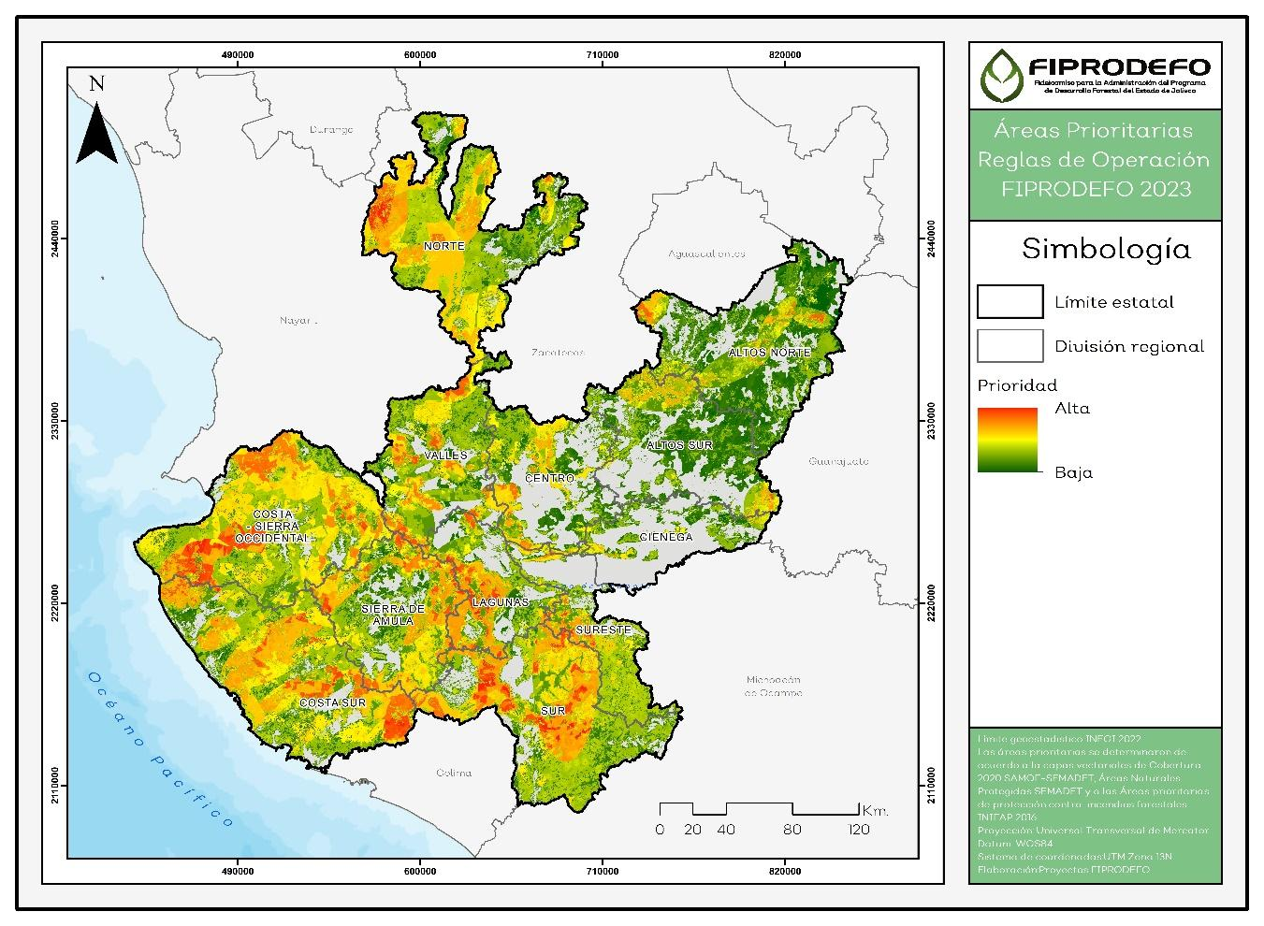

Tabla: Grado de prioridad de acuerdo a la superficie de cobertura forestal por municipio y región.
Límite estadístico (INEGI) |  | PRIORIDAD |  |  |  |  | SUP. POTENCIAL (HA)
Región | Municipio | Muy Alta | Alta | Media | Baja | Muy Baja | Total
Sur | San Gabriel | 9156.39 | 17937.79 | 9779.70 | 11122.64 | 9843.85 | 162421.71
 | Tecalitlán | 8216.12 | 31584.23 | 10872.02 | 64712.03 | 14044.31
 | Tamazula de Gordiano | 7953.78 | 31761.08 | 62350.54 | 26939.30 | 7364.45
 | Tuxpan | 4573.10 | 8275.45 | 13420.49 | 16486.46 | 12040.40
 | Zapotitlán de Vadillo | 2618.21 | 6792.17 | 8094.40 | 6089.90 | 4014.36
 | Zapotiltic | 1737.22 | 2088.28 | 6161.59 | 7573.92 | 4805.50
 | Jilotlán de los Dolores | 934.67 | 5111.02 | 4322.06 | 80505.90 | 40250.66
 | Tonila | 424.25 | 502.13 | 1624.04 | 4047.64 | 3989.99
 | Pihuamo | 269.20 | 3863.07 | 12674.33 | 39210.00 | 19431.75
 | Gómez Farías | 212.19 | 4922.93 | 6506.79 | 15002.66 | 5346.33
 | Tolimán | 176.29 | 10064.08 | 17956.08 | 6936.28 | 7525.78
 | Zapotlán el Grande | 1.27 | 3246.82 | 2103.79 | 4047.77 | 2144.36
Costa-Sierra Occidental | Cabo Corrientes | 21508.15 | 25825.43 | 38125.23 | 54973.78 | 13484.91 | 159715.05
 | Talpa de Allende | 9772.42 | 18239.30 | 46654.05 | 80637.24 | 36893.70
 | Mascota | 2020.66 | 3859.27 | 75468.71 | 72543.46 | 14333.73
 | Guachinango | 604.06 | 9682.60 | 33735.26 | 24667.26 | 13619.96
 | Mixtlán | 528.77 | 14892.32 | 25009.06 | 15441.56 | 5581.07
 | San Sebastián del Oeste |  | 39847.64 | 40065.73 | 20823.93 | 8960.08
 | Puerto Vallarta |  | 7462.12 | 30312.75 | 11199.95 | 8028.96
 | Atenguillo |  | 5472.31 | 26592.11 | 11356.05 | 7803.69
Costa Sur | Cuautitlán de García Barragán | 7958.12 | 28014.33 | 51712.01 | 26824.22 | 13619.47 | 135993.27
 | Villa Purificación | 3179.09 | 23538.99 | 81204.43 | 52406.70 | 18968.04
 | Tomatlán | 2443.50 | 34103.97 | 72999.15 | 104548.99 | 58480.24
 | Casimiro Castillo | 1078.30 | 11749.88 | 11275.18 | 11586.30 | 7069.86
 | La Huerta | 514.92 | 23412.17 | 71807.84 | 58672.05 | 33473.00
 | Cihuatlán |  |  | 7282.66 | 19311.31 | 11516.33
Sierra de Amula | Tecolotlán | 2508.96 | 21589.96 | 18198.72 | 16052.53 | 11773.09 | 78052.73
 | Chiquilistlán | 2147.56 | 13033.59 | 6594.44 | 3875.12 | 4087.73
 | Ayutla | 2041.59 | 6068.65 | 14856.89 | 31318.72 | 21453.13
 | Tonaya | 359.04 | 3083.61 | 12435.63 | 9180.09 | 4298.99
 | Cuautla | 81.12 | 4854.75 | 17995.16 | 11510.57 | 5144.99
 | Ejutla | 14.21 | 6543.53 | 9261.92 | 10286.48 | 3606.70
 | Tenamaxtlán | 14.20 | 291.52 | 1953.90 | 7852.46 | 7282.35
 | El Limón | 11.59 | 1541.82 | 3090.86 | 3039.10 | 3235.32
 | Atengo | 2.59 | 2738.51 | 8646.96 | 14649.18 | 13724.59
 | Autlán de Navarro |  | 5783.88 | 15084.44 | 22663.60 | 11199.27
 | Juchitlán |  | 4474.27 | 4268.02 | 5847.56 | 4779.19
 | Tuxcacuesco |  | 860.67 | 24426.22 | 9191.07 | 5927.53
 | El Grullo |  | 7.13 | 3109.22 | 3512.58 | 3966.16
 | Unión de Tula |  |  | 3891.34 | 11792.36 | 16984.67
Lagunas | San Martín Hidalgo | 48.49 | 2716.07 | 3533.04 | 4097.34 | 9418.12 | 77205.58
 | Acatlán de Juárez | 0.52 | 13.57 | 135.40 | 2427.58 | 4129.09
 | Tapalpa | 5188.59 | 22313.27 | 10015.43 | 7247.08 | 11015.40
 | Atemajac de Brizuela | 5144.86 | 15784.80 | 7327.83 | 3916.81 | 3407.08
 | Techaluta de Montenegro | 1293.38 | 2701.70 | 1449.54 | 1038.77 | 1240.53
 | Atoyac | 287.19 | 1359.79 | 1638.19 | 14247.86 | 17341.17
 | Sayula | 1038.18 | 6470.17 | 2275.68 | 3504.82 | 1436.85
 | Cocula | 975.31 | 1839.11 | 4855.88 | 10009.92 | 8724.03
 | Amacueca | 746.10 | 3413.87 | 2141.89 | 2199.24 | 2523.52
 | Teocuitatlán de Corona |  | 204.02 | 3962.84 | 9991.77 | 7920.10
 | Zacoalco de Torres | 184.71 | 3299.46 | 7894.05 | 12231.18 | 7553.78
 | Villa Corona | 113.88 | 2068.54 | 5199.23 | 8043.78 | 4508.52
Norte | Mezquitic | 10777.95 | 57215.11 | 131551.67 | 120211.31 | 15926.93 | 76299.19
 | San Martín de Bolaños | 4.07 | 2323.31 | 45256.74 | 15122.99 | 5615.91
 | Villa Guerrero | 3.29 | 2150.92 | 18566.16 | 29346.03 | 10725.94
 | Huejúcar |  | 1853.57 | 3842.37 | 9481.00 | 10867.67
 | Huejuquilla el Alto |  | 1506.70 | 13741.78 | 34795.18 | 18776.09
 | Bolaños |  | 262.84 | 35117.83 | 44228.32 | 6914.03
 | Santa María de los Ángeles |  | 181.95 | 4504.30 | 9007.09 | 9654.81
 | Chimaltitán |  | 9.86 | 30679.29 | 22653.84 | 9162.30
 | Colotlán |  | 9.63 | 7536.61 | 23712.38 | 23887.48
 | Totatiche |  | 0.00 | 361.60 | 28057.41 | 20317.41
Valles | Tequila | 387.02 | 12417.33 | 30577.99 | 85740.27 | 27398.86 | 53014.85
 | San Juanito de Escobedo | 377.53 | 969.43 | 1425.29 | 7105.22 | 3350.47
 | Amatitán | 377.53 | 969.43 | 1425.29 | 7105.22 | 3350.47
 | Ameca | 353.94 | 15030.95 | 14998.35 | 26962.75 | 16115.49
 | Magdalena | 168.05 | 2785.81 | 6514.65 | 8009.57 | 5524.97
 | Etzatlán | 151.50 | 5418.72 | 11348.98 | 10748.30 | 4492.86
 | Tala | 107.86 | 3121.49 | 9274.67 | 11690.14 | 7575.14
 | Hostotipaquillo | 30.57 | 4675.60 | 21292.83 | 30283.37 | 14403.75
 | San Marcos | 17.74 | 2600.13 | 4982.27 | 12148.92 | 6948.37
 | Ahualulco de Mercado | 10.18 | 2865.65 | 5116.46 | 8468.34 | 4323.82
 | El Arenal |  | 178.39 | 317.77 | 810.95 | 3689.90
 | Teuchitlán |  |  | 1166.09 | 9672.21 | 7726.97
Sureste | Concepción de Buenos Aires | 1834.68 | 6351.73 | 5325.98 | 5083.36 | 7698.93 | 14923.18
 | Mazamitla | 1349.53 | 8699.36 | 5737.83 | 8821.12 | 2547.58
 | La Manzanilla de la Paz | 83.58 | 1257.69 | 2006.38 | 2740.05 | 3411.03
 | Jocotepec |  | 2243.75 | 6342.31 | 7439.97 | 5404.19
 | Chapala |  | 621.58 | 3024.34 | 1652.20 | 1952.76
 | Tuxcueca |  | 574.96 | 1516.51 | 5247.02 | 2626.04
 | Santa María del Oro |  | 92.72 | 219.02 | 63132.48 | 13247.66
 | Quitupan |  |  | 10766.89 | 36974.85 | 15009.81
 | Valle de Juárez |  |  | 1519.50 | 11362.70 | 4474.09
 | Tizapán el Alto |  |  | 266.12 | 5064.97 | 4314.73
Altos Norte | Encarnación de Díaz | 6.30 | 386.21 | 3850.59 | 20624.10 | 52534.39 | 14971.87
 | Lagos de Moreno | 4.50 | 6201.54 | 15025.57 | 83308.85 | 91922.79
 | Teocaltiche |  | 5796.56 | 7632.55 | 19629.16 | 35196.15
 | Villa Hidalgo |  | 2198.93 | 11362.47 | 6714.92 | 12598.58
 | Ojuelos de Jalisco |  | 219.92 | 2837.79 | 10659.12 | 73674.08
 | San Juan de los Lagos |  | 157.91 | 4565.77 | 30716.24 | 42926.35
 | Unión de San Antonio |  |  | 262.94 | 13136.17 | 41051.36
 | San Diego de Alejandría |  |  |  | 5160.95 | 24605.04
Centro | Tlajomulco de Zúñiga | 176.71 | 5521.36 | 8920.44 | 10213.34 | 16501.39 | 14732.71
 | Ixtlahuacán de los Membrillos | 92.88 | 1881.34 | 25734.09 | 15750.25 | 23145.99
 | Zapopan | 9.40 | 5628.78 | 26870.22 | 27135.99 | 21393.64
 | Ixtlahuacán del Río | 2.72 | 1099.69 | 2464.05 | 2527.27 | 2744.70
 | San CristÃ³bal de la Barranca | 1.00 | 318.62 | 7406.55 | 32077.09 | 12280.63
 | Cuquío |  | 0.23 | 3549.58 | 8999.28 | 13036.94
 | Zapotlanejo |  |  | 4409.76 | 8367.43 | 20083.93
 | Juanacatlán |  |  | 1722.92 | 2131.53 | 7644.33
 | Tonalá¡ |  |  | 954.35 | 1679.24 | 3056.08
 | Guadalajara |  |  | 553.87 | 366.35 | 215.19
 | El Salto |  |  | 0.12 | 56.40 | 4395.36
 | San Pedro Tlaquepaque |  |  |  | 2.75 | 1134.13
Altos Sur | Jesús María | 19.48 | 2848.23 | 9739.37 | 23468.86 | 12883.41 | 5444.32
 | Mexticacán |  | 1019.55 | 10067.04 | 7955.90 | 9619.13
 | Jalostotitlán |  | 690.38 | 12650.37 | 18014.21 | 15681.75
 | Yahualica de González Gallo |  | 471.62 | 2652.35 | 15465.35 | 17908.30
 | Cañadas de Obregón |  | 392.59 | 7521.84 | 8996.27 | 8315.94
 | Valle de Guadalupe |  | 2.47 | 675.73 | 6748.42 | 15977.49
 | Tepatitlán de Morelos |  |  | 1515.03 | 20008.46 | 46880.29
 | Acatic |  |  | 1347.20 | 1429.18 | 3637.21
 | San Ignacio Cerro Gordo |  |  | 746.62 | 1480.26 | 8341.44
 | Arandas |  |  | 44.81 | 9889.95 | 43175.94
 | San Miguel el Alto |  |  |  | 14087.75 | 53707.44
 | San Julián |  |  |  | 3318.88 | 20707.46
Ciénega | Poncitlán |  | 875.78 | 6616.09 | 4579.61 | 5144.54 | 1253.15
 | Degollado |  | 183.73 | 3091.95 | 14307.80 | 10006.35
 | Ocotlán |  | 161.90 | 1336.76 | 3050.30 | 2553.40
 | La Barca |  | 16.00 | 1625.56 | 733.40 | 1153.35
 | Zapotlán del Rey |  | 15.75 | 1220.44 | 10775.44 | 8452.44
 | Ayotlán |  |  | 622.89 | 9129.45 | 12506.14
 | Jamay |  |  | 130.85 | 2038.97 | 1222.39
 | Tototlán |  |  | 1.31 | 4081.46 | 7508.73

